A Project Report On

Inventory Management System
Submitted in partial fulfillment of the requirement for the
BCA Semmester-4 Python Programming Final Examination.
Bachelors Of Computer Application
(B.C.A)
Academic Year 2025 – 26

Ghetiya Shiya – 92400527111

Internal Guide
Prof. AMIT GOHEL


Rajkot-Morbi Road, At &PO :Gauridad, Rajkot 360 003. Gujarat.India.

CONTENTS
Chapters | Particulars | Page No.
1 | SYNOPSIS | 3
2 | PREAMBLE | 3
2.1  2.2  2.3  2.4 | General Introduction | 4
 | Statement of Problem | 4
 | Objective and Scope of the Study | 4
 | Module Description with functionality | 5
3 | SYSTEM DESIGN AND DEVELOPMENT | 7
3.1  3.2  3.3  3.4 | Data Flow Diagram (DFD) | 7
 | Table Structure | 12
 | Menu Design | 12
 | Screen Design (Screen shots with short description) | 13
4 | CONCLUSION | 20
5 | LEARNING DURING PROJECT WORK | 20
6 | BIBLIOGRAPHY | 21
6.1 | Online References | 21
6.2 | Offline References | 21

1. SYNOPSIS
Inventory Management System is a Python project that is used to manage the stock information of the products available in a store. This project assists the user to add products, update quantity of stock, delete stock data, and even check what stocks are available to the user.The main idea behind developing this project is to make the life of the user easy by automating the process of managing inventory information.
Conventionally, such information was kept in notebooks which took lot of time and could result in inaccuraies.This project has been developed using the programming language of Python and can be implemented with either Tkinter or SQLite/MySQL. Using this project, a person can track the names of the product, the company names, stock quantity, price per piece, and even stock worth.
Such a project can prove to be beneficial to small businesses that require daily stock management.

2. PREAMBLE
2.1 General Introduction
Inventory management refers to the management of storing,organizing, maintaining, and controlling goods or products in a business. All the organizations that deal with products require an appropriate system for managing stocks.
The Inventory Management System is aimed at helping the users manage their product inventory digitally. The system manages the data electronically by storing it in the database, hence facilitating easy searching and updating of the product inventory.

This project can be applicable in the following places:
- Retail shops
- Mobile shops
- Grocery shops
- Clothing shops
- Warehouses
- Small-scale businesses
It enhances efficiency and minimizes stock management problems.

2.2 Problem Statement
In many small companies, records of inventory are manually recorded in registers or spreadsheets. This brings about various problems including:
- Problem in monitoring available inventories
- Manual data entry which is time consuming
- Problems in updating quantities
- Duplications of products
- Problems in identifying items in low inventories
- Data lost because of use of paper documentation
- Lack of ability to generate quick reports
Hence, there exists a need for an Inventory Management System which would be computerized.
2.3 Objectives and Scope of the Project
Objectives
The following are the main objectives of this project:
- Develop an inventory management system using Python
- Keep record of the details of each product in an organizedmanner
- Add, modify, delete and search for products
- Keep stock and price details of each product
- Avoid mistakes made in manual stock management
- Provide a friendly interface to manage inventory
- Show availability of products clearly

Scope of the Project
The scope of this project will involve:
- Keeping record of products in a small company
- Keep stock details of each product
- Show immediate stock availability
- Update stock details in case there is any sale or new stock arrives
- This can be expanded in the future to include other activities such as billing, sales reports, etc.

2.4 Module Description with Functionality
The Inventory Management System is divided into the following modules:
1. Add Product Module
This module allows adding new products to the inventory system database.
Functionality:
- Product ID entry
- Product Name entry
- Company Name entry
- Quantity entry
- Price entry
- Saving product details
2. View Product Module
This module displays all the products stored in the inventory database in a table.
Functionality:
- Displaying all products
- Company name, product name, quantity, and price display
- Ease of understanding stock details

3. Update Product Module
This module updates the details of the already entered products.
Functionality:
- Selection of product by its ID
- Modification of the product name
- Modification of the company name
- Modification of quantity
- Modification of price
- Updating information

4. Delete Product Module
This module deletes the unwanted products from the inventory database.
Functionality:
- Selection of product by its ID
- Permanent deletion of the product record
- Preventing duplicacy and unnecessary entries

5. Search Product Module
This module helps find a particular product easily.
Functionality:
- Searching by Product ID
- Searching by Product Name
- Displaying matching records

6. Stock Report Module
This module provides a report of the stock available.
Functionality:
- Total number of products display
- Total quantity of stock display

3. SYSTEM DESIGN AND DEVELOPMENT

3.1 Data Flow Diagram (DFD)

Level 0 DFD
User → Inventory Management System → Database
Flow Process:
- User inputs product information
- System processes the information
- Data is saved/extracted from the database
- Result is displayed back to the user
Explanation of DFD
- User provides input such as adding, updating, deleting, or searching product data.
- The system processes the user input.
- The database saves or retrieves product data.

Diagram of DFD
+------------------+
| USER |
| (Admin / Staff) |
+--------+---------+
|
Add / Update / Delete / Search Request
|
v
+-----------------------------+
| INVENTORY MANAGEMENT |
| SYSTEM |
+-------------+---------------+
|
Store / Retrieve Product Data
|
v
+----------------------+
| INVENTORY DATABASE |
+----------------------+
|
Product Details / Reports
|
v
+------------------+
| USER |
| (Admin / Staff) |
+------------------+

Level 1 DFD
User → Add Product → Database
User → View Product → Database
User → Update Product → Database
User → Delete Product → Database
User → Search / Report → Database

Flow of Process
- Add Product will store product details in the database.
- View Product will retrieve product details from the database.
- Update Product will modify the product details stored in the database.
- Delete Product will delete product details from the database.
- Search/Report will display product details that are searched for and also generate stock reports.
Explanation of DFD
In Level 1 DFD, Inventory Management System consists of five components, namely:
- Add Product
- View Product
- Update Product
- Delete Product
- Search
Diagram of DFD
+------------------+
| USER |
| (Admin/Staff) |
+--------+---------+
|
v
+-----------------------------+
| 1.0 ADD PRODUCT MODULE |
+-------------+---------------+
|
v
+----------------------+
| INVENTORY DATABASE |
+----------------------+

+------------------+
| USER |
+--------+---------+
|
v
+-----------------------------+
| 2.0 VIEW PRODUCT MODULE |
+-------------+---------------+
|
v
+----------------------+
| INVENTORY DATABASE |
+----------------------+

+------------------+
| USER |
+--------+---------+
|
v
+-----------------------------+
| 3.0 UPDATE PRODUCT MODULE |
+-------------+---------------+
|
v
+----------------------+
| INVENTORY DATABASE |
+----------------------+

+------------------+
| USER |
+--------+---------+
|
v
+-----------------------------+
| 4.0 DELETE PRODUCT MODULE |
+-------------+---------------+
|
v
+----------------------+
| INVENTORY DATABASE |
+----------------------+

+------------------+
| USER |
+--------+---------+
|
v
+-----------------------------+
| 5.0 SEARCH / REPORT MODULE |
+-------------+---------------+
|
v
+----------------------+
| INVENTORY DATABASE |
+----------------------+

3.2 Table Structure
Table Name:Inventory
Field Name | Data Type | Description
product_id | INTEGER / INT | Unique ID of product
company_name | VARCHAR(100) | Name of company/brand
product_name | VARCHAR(100) | Name of product
quantity | INTEGER | Available stock quantity
price | FLOAT / REAL | Price per unit
total_value | FLOAT / REAL | Quantity × Price

Primary Key
product_id
Description
This table stores all product-related details and helps in maintaining stock records.

3.3 Menu Design
Main Menu:
- Add Product
- Delete Product
- Update Product
- View Product
- Search Product
- Stock Report
- Exit

Menu Function:
- Add Product → Insert new product into database
- View Products → Display all products
- Update Product → Modify product details
- Delete Product → Remove product from inventory
- Search Product → Find a product
- Stock Report → Show summary and stock analysis
- Exit → Close the application

3.4 Screen Design (Screen shots with short description)

3.1. Home Screen
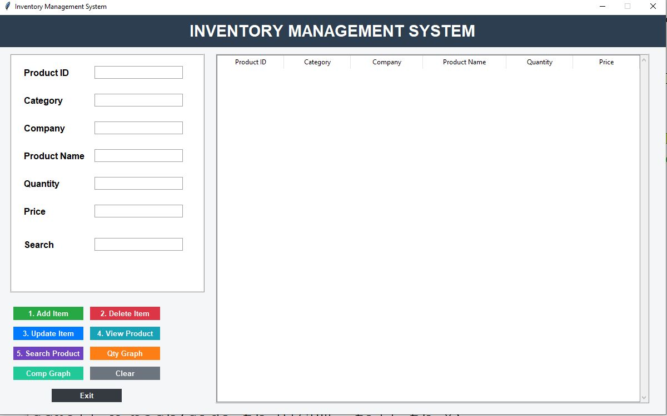

Description:

The main window of the application showing buttons or menu options such as Add, View, Update, Delete, Search, and Exit.

3.2. Add Product Screen
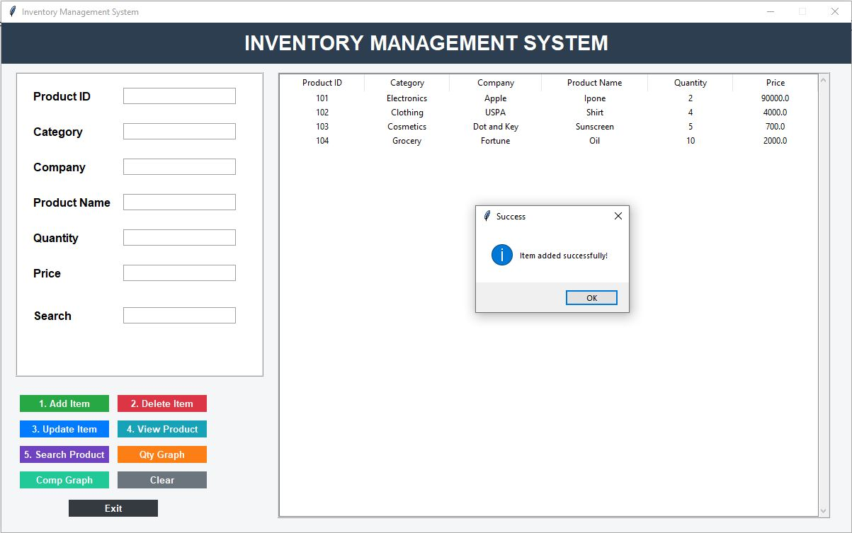–––––
Description:
This screen will contain input field for:
- Product ID
- Company Name
- Product Name
- Quantity
- Price
Also, a Save/Add button to add record.

3.3. Update Product Screen

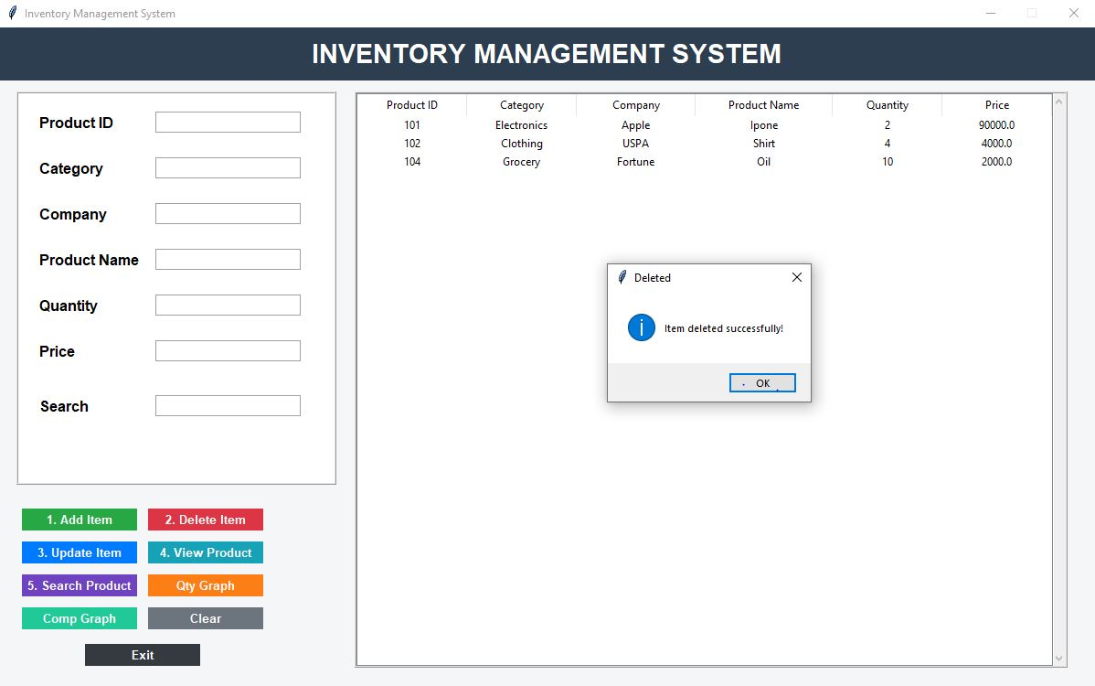

Description:
This screen will allow user to choose a product and update its information. The modified information is then saved.

3.4. Delete Product Screen

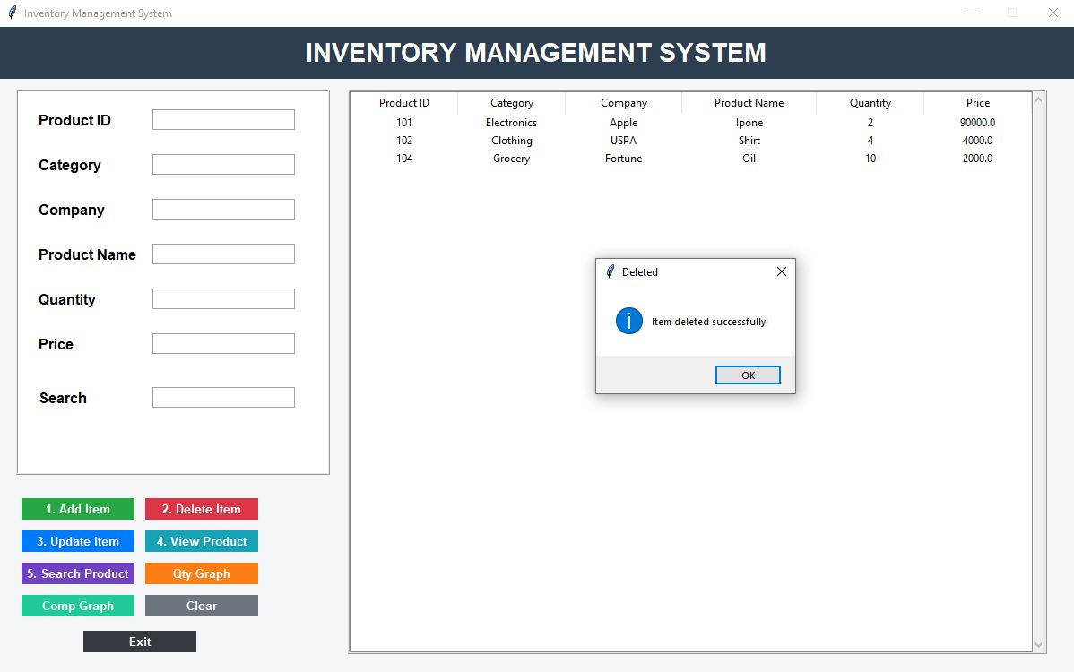

Description:
This screen will allow the user to delete record of selected product.

3.5.View Product Screen
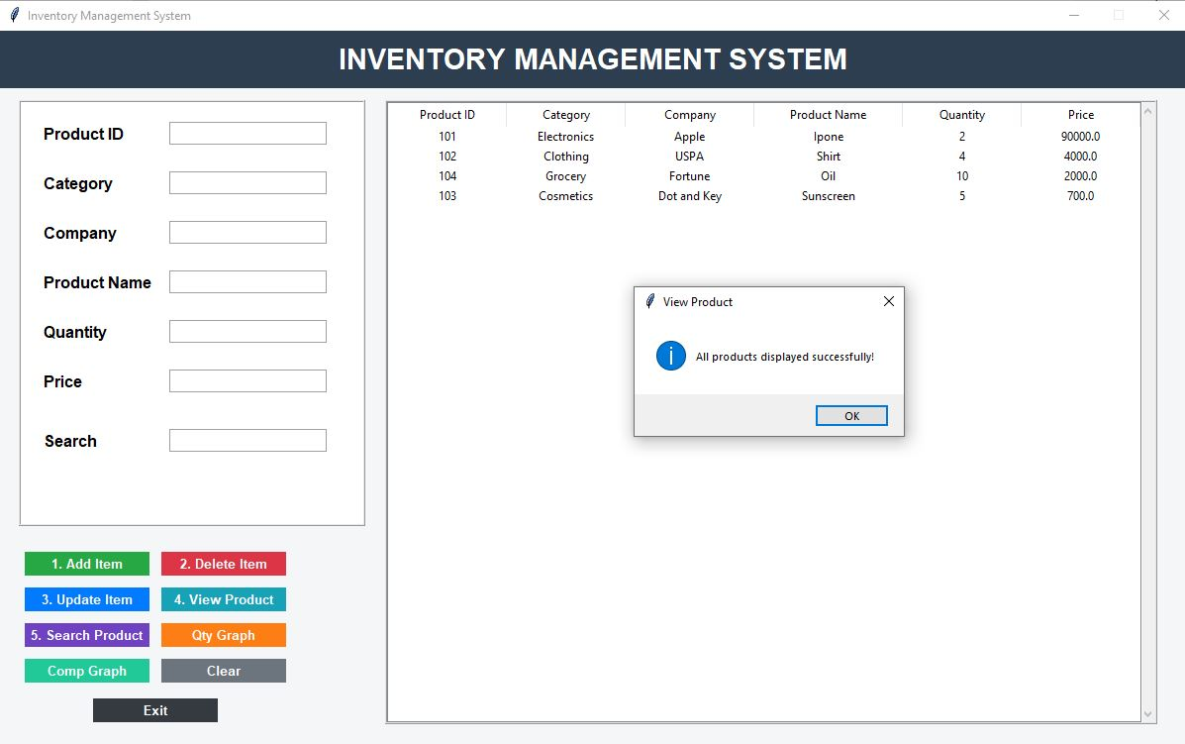

Description:
All products are listed in this screen by showing their records in a table format (treeview or Tkinter).

Fields displayed:

- Product ID
- Company Name
- Product Name
- Quantity
- Price
- Total Value

3.6. Search Product Screen

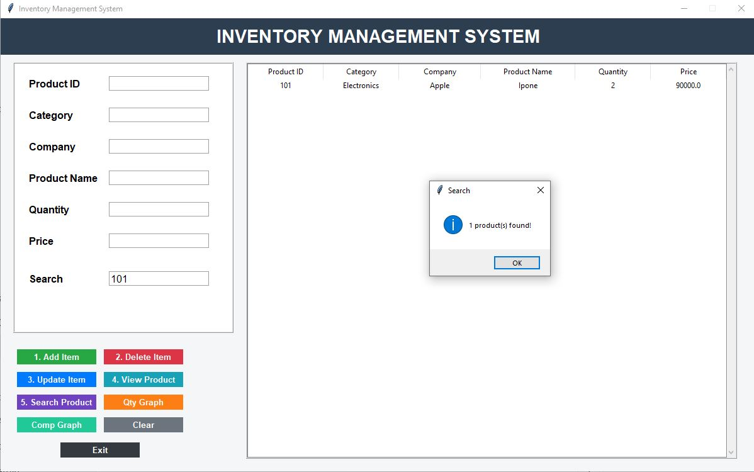

Description:
Products can be searched based on either Product ID or Product Name in this screen.

Bar Graph
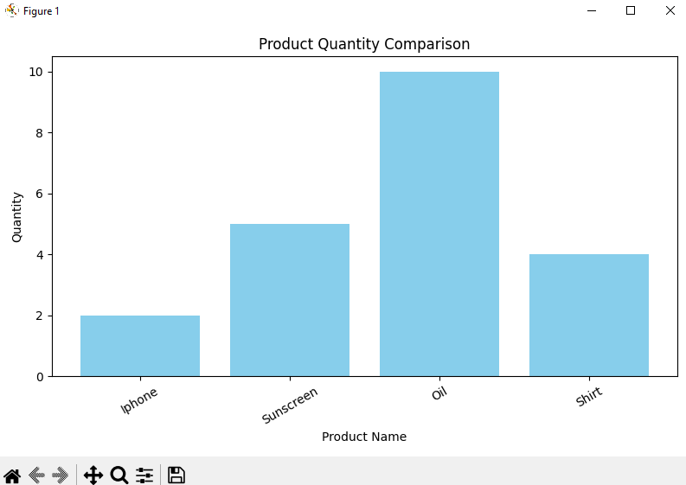

Pie Chart
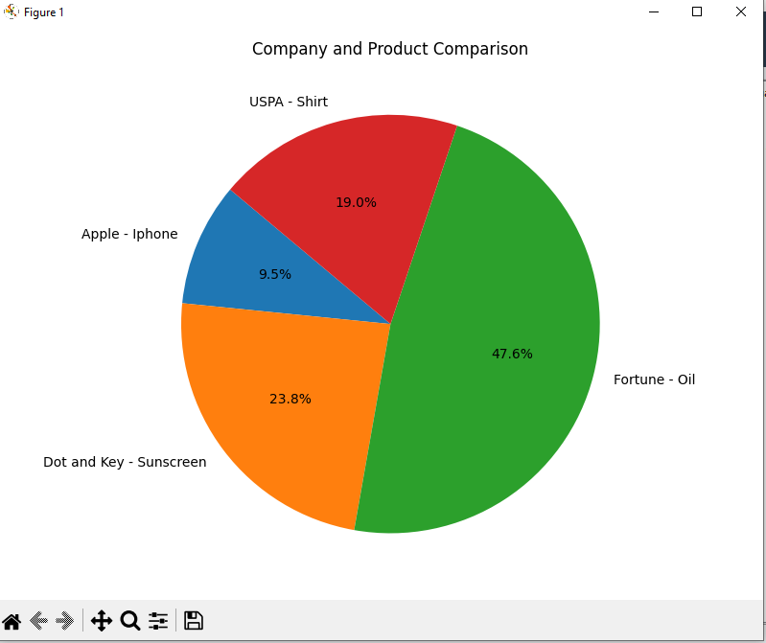

4. CONCLUSION
The Inventory Management System is a practical Python project that assists in managing stocks of various products. It serves as an alternative method to manually managing the stock and is much more efficient than the manual process.

It is quite useful for:
- Simplifying stock management processes
- Enhancing accuracy in stock management
- Conserving time spent in searching and updating records
- Ensuring systematic organization of product information
- Maintaining proper control over the inventory

It is particularly useful for small scale businesses, shops, and stores where daily inventory management is required. This project provides an insight into creating business applications using Python.

5. LEARNING DURING PROJECT WORK

Learning during development of the Inventory Management System includes the following:
- Knowledge of inventory management problems faced by organizations
- Application of programming using Python
- GUI Designing using Tkinter
- Database connectivity using SQLite/MySQL
- Performing CRUD operations (Create, Read, Update, Delete)
- Handling errors and data validation
- Designing tables
- Creating menu-driven applications
- Logical thinking and problem solving skills
- Format of project documentation
This project has helped me learn and grow both technically as well as practically.

6. BIBLIOGRAPHY
6.1 Online References:
- https://www.python.org
- https://www.w3schools.com/python
- https://matplotlib.org

6.2 Offline References
- Notes on Python programming
- Classroom Lecture Notes
- Faculty Guidance

